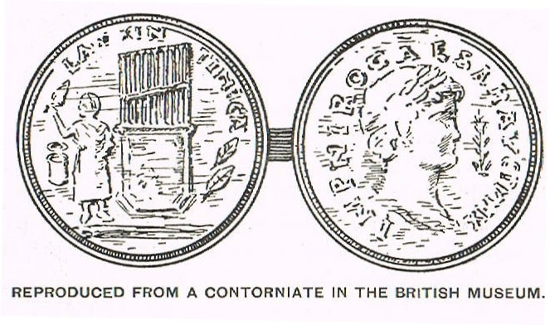
A Contorniate of Nero

Allan Speedy

N
ero Claudius Caesar Augustus Germanicus, the last of the Julio-Claudian dynasty, was born near Rome in AD 37. He was adopted by his great-uncle, the Emperor Claudius, thereby becoming the emperor’s heir and successor. Nero succeeded to the throne in AD 54 following Claudius' death.
In the British Museum there is a type of Roman medal called a ‘contorniate’, believed to date from the reign of Constantine the Great (AD 272 – AD 337), which obverse bears the head of Nero (and the usual legend) and reverse seems to feature the form of a wind organ with nine pipes with a bellows or bag beneath. Some have interpreted this as an early and Roman form of bagpipe.

A contorniate (or contourniate) is a species of medal or medallion of bronze, having a deep furrow on the contour or edge, as if the object had been turned in the lathe. Contourniated medallions were supposed to have been struck in the days of Constantine and his successors. All we have remaining of these types of medals seem to have been made about the same time. It has been conjectured that contorniates appear to have been struck around the 13th century; other antiquaries go back centuries earlier. The manner of the work seems to have had its origin in ancient Greece, and to have been appropriated to honour the memories of great men, principally those who had gained prizes at games. It is possible they were gaming tokens, faction badges or souvenirs.

The bagpipe is of great antiquity. Legend has it that Noah had a piper and used to dance to the music over two crossed vine plants, a tale in anticipation perhaps, of the Scottish dance performed over crossed swords. Bagpipes have been noted in ancient Persia, Egypt, Babylonia, Greece, Asia Minor, Assyria and the Holy Land. The Roman infantry used the bagpipe for marching purposes and this has been represented in contemporary sculpture. What appear to be crude representations of bagpipes have appeared on Roman coins.
Nero fancied himself as a musician and composer. The Roman historian Tacitus, who was born a generation after Nero, records that the emperor enjoyed singing to the lyre or harp. According to Suetonius, also born a generation after Nero and the author of The Lives of Twelve Caesars, Nero’s musical compositions were performed by other musicians, imitation being the greatest form of flattery.
At first, Nero only performed for a private audience, but later performed in public, much to the disgust of the Roman upper crust. Nero was encouraged to sing and perform in public by the Senate, his inner circle and the people. He had statues representing him in the guise of a lyre-player; and he had a coin struck with the same device. Some writers call the instrument on which Nero played ‘a flute with a bladder under the performer’s arm.’ Hoberman writing in ‘Coin News’ magazine writes that ‘He was moreover, known to perform successively on water-organ, flute and bagpipes…’ but does not quote any sources for this although it appears to be derived from Suetonius.

The Great Fire of Rome, in Latin Magnum Incendium Romae, was an urban fire that started on 19th July AD 64. According to Tacitus, it burned for five days, and just as it was thought to be extinguished, it re-ignited. Of the fourteen districts of Rome, four were unharmed, three were levelled to the ground, and seven were severely damaged. The only other contemporaneous historian to mention the fire was Pliny the Elder (AD 23 – AD 79), who wrote about it in passing: trees that lasted ‘down to the Emperor Nero's conflagration’.
Surprisingly other historians who lived through the period make no mention of the fire. Nero goes down in history most famously as the emperor who ‘fiddled while Rome burned’. Tacitus however dismisses the notion of Nero ‘fiddling’ when he wrote ‘a rumour had gone forth everywhere that, at the very time when the city was in flames, the emperor appeared on a private stage and sang of the destruction of Troy, comparing present misfortunes with the calamities of antiquity.’

Nero started to lose his grip on power from March 68. ‘Towards the end of his life, he publicly vowed, that if his power in the state was securely re-established, he would, in the spectacles which he intended to exhibit in honour of his success, include a performance upon organs, as well as upon flutes and bagpipes ….’ As the fiddle was not developed for another thousand years after Nero’s death perhaps the legend should instead have had Nero playing the bagpipe while Rome burned!
Nero committed suicide on 9 June AD 68. As his grave was being prepared, he said again and again “What an artist the world is losing!" He was succeeded by the Emperor Galba.
*****

Allan L.T Speedy BCom MCom FRAS

REFERENCES:
BAKES, J., ‘Coin News’, Volume 36 No.4 April 1999, “Bread and Circuses”
Hoberman, G., ‘Coin News’, Volume 32 No.6 June 1995
MANSON, W.L., ‘The Highland Bagpipe: Its History, Literature and Music. With Some Account of the Traditions, Superstitions, and Anecdotes Relating to The Instrument and Its Tunes (London 1901)
WIKIPEDIA, Various Articles

One definition of a bagpipe is ‘A wind instrument whose fixed characteristic has always been two or more reed pipes attached to and sounded by a wind chest or bag, which bag has in turn been supplied either by the lungs of the performer or by a bellows’ (Manson p59).
Manson, p31-32
Manson, p34
Manson, p34
TACITUS, ‘The Annals’, Book 14.14
Suetonius, ‘The Lives of Twelve Caesars, Life of Vitellius’, 11.2
TACITUS, ‘Annals’ 15.33; Suetonius, ‘The Lives of Twelve Caesars, Life of Nero’, 21.
Tacitus, ‘Annals’ 16.4; Suetonius, ‘The Lives of Twelve Caesars, Life of Vitellius’ 11; IBID, ‘Life of Nero’, 21.
Suetonius, ‘The Lives of Twelve Caesars, Life of Nero’ 25
Manson, p33
‘Coin News’, p32
TACITUS, ‘The Annals’ 15.40
Pliny the Elder, ‘Natural Histories’, XVII
Nero was also notorious as the persecutor of the early Christians.
TACITUS, ‘The Annals’, Book 15.39
SUETONIUS, Nero LIV
Suetonius, Nero XLIX

